Capstone Project 3
An end-to-end customer analytics system
that transforms clickstream and transaction data into real-time intent monitoring
and actionable marketing insights

Concepcion Itchon
January 13, 2026
Executive Summary

This capstone project develops an end-to-end Customer Analytics System for an e-commerce business by integrating transactional data and clickstream behavior to drive both strategic marketing insights and real-time conversion optimization.
The project delivers two complementary models. First, a customer segmentation model uses behavioral, engagement, and value-based features to identify five distinct customer segments. Using PCA and multiple clustering techniques, DBSCAN emerged as the strongest model, uncovering natural, non-linear behavioral groupings that traditional clustering approaches could not detect. The resulting segments reveal clear differences in engagement intensity, purchase efficiency, and shopping patterns, enabling targeted personalization, onboarding strategies, and frequency-driven interventions. Importantly, the segmentation framework is designed to be operationalized as a persistent customer attribute rather than a static analytical output.
Second, a session-level purchase prediction model leverages real-time behavioral signals to predict purchase intent during an active browsing session. After rigorous leakage detection and removal, Gradient Boosting delivered strong and stable performance. Through decision threshold tuning, the model was optimized for early intervention, capturing the majority of purchasing sessions while maintaining acceptable precision. Rather than simply predicting who will buy, the model functions as a real-time intent monitor, identifying sessions with declining or low purchase probability while users are still on the site—enabling proactive intervention instead of post-hoc analysis.
Together, these models demonstrate how behavioral data can be transformed into actionable intelligence that supports personalized experiences, smarter marketing spend allocation, and real-time conversion optimization, while maintaining strong analytical rigor and business relevance.

Table of Contents

1.0 Problem Statement

2.0 Data Wrangling through Cleaning

3.0 Segmentation Model

3.1 Feature Engineering & Data Integration

3.2 EDA

3.3 Pre-processing and Modeling

3.4 Recommended Actions and Future Research

4.0 Purchase Prediction Model

4.1 Feature Engineering & Data Integration

4.2 EDA

4.3 Pre-processing and Modeling

4.4 Recommended Actions and Future Research

1.0 Problem Statement

Modern e-commerce companies collect massive amounts of behavioral and transactional data, yet many struggle to transform these raw signals into a cohesive understanding of customer behavior. This limits the ability to personalize experiences, allocate marketing spend efficiently, and intervene proactively along the purchase journey. The availability of both transactional purchase records and detailed clickstream logs presents an opportunity to build a comprehensive analytics framework that supports strategic decision-making and real-time customer engagement.

This capstone project aims to develop an end-to-end Customer Analytics System that leverages multi-source customer data to:

1.1 Identify meaningful customer segments

1.2. Create a model to predict purchase

Both models will inform marketing strategies and campaigns to generate more e-commerce revenue.

2.0 Data Wrangling through cleaning

The goal of the Data Wrangling phase was to transform six raw retail/e-commerce datasets into a clean, consistent, analysis-ready dataset that could support downstream modeling and insights.

2.1. Initial Review and Structural Understanding of Each Dataset
The structure, column types, completeness, and potential anomalies were explored for 6 datasets.

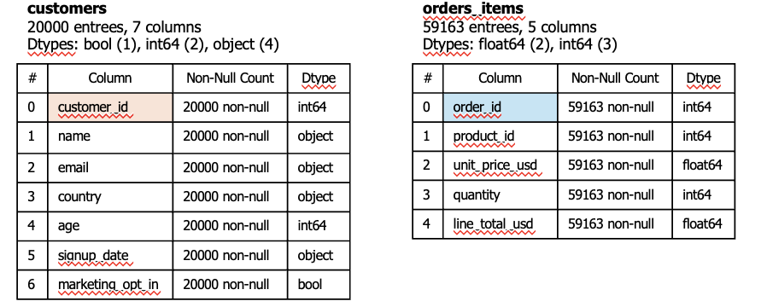

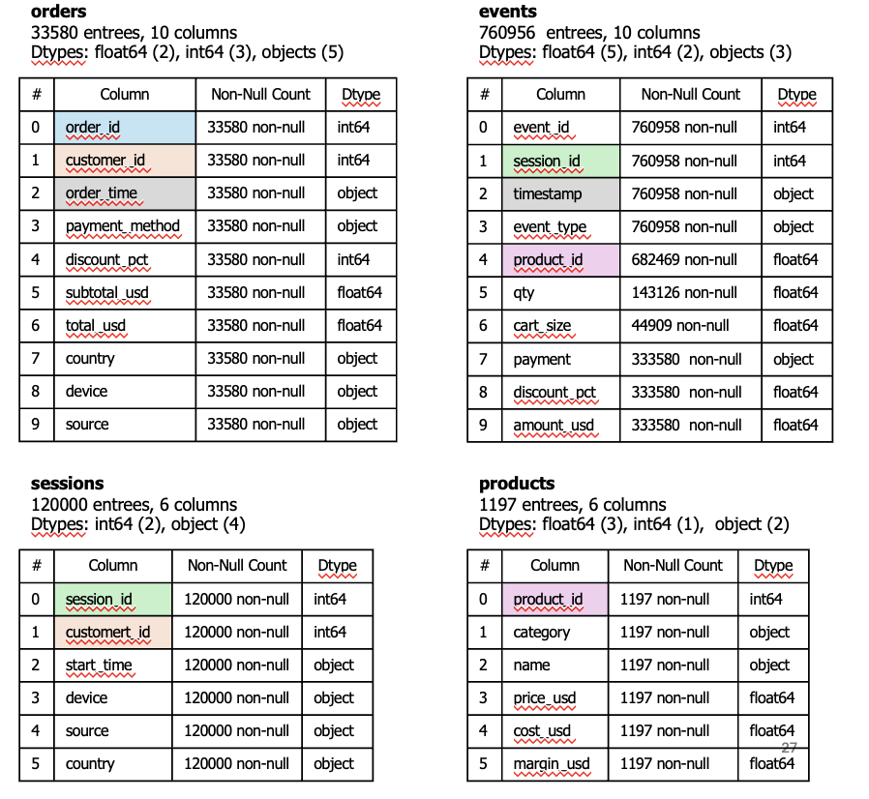
For each dataset:
- Displayed head(), info(), and summary statistics.
- Assessed data types and identified necessary conversions (e.g., timestamps stored as strings).
- Checked for missing values, duplicates, and outliers.

2.2 Data Cleaning and Type Corrections
The dataframes were generally in good, clean state. A few actions were taken:

a. Datetime Conversion
Several columns representing timestamps were stored as text. Specifically: 'order_time' in orders df, 'timestamp' in events df, 'start_time' in sessions df. These were converted to datetime.

b. Duplicates
- orders df - 73 exact duplicates were dropped, 37 records with the same 'order_id' and 'product_id', the first occurrence was kept and others drop.
- customers_df - 3,629 record of duplicate names, overwhelming majority were confirmed to be different customers (ie- they came from different countries and had different ages).

c. Null entries - only events df had null entries (product_id, qty, cart_size, payment, discount_pct, amount_usd). This is expected as not all events will result to a purchase. Ensured all null entries were coded as 'NaN'.

Customer Segmentation Model

3.1. Feature Engineering and Dataset Integration
To prepare the combined dataset for modeling and analysis, several features were engineered, such as:

- from orders df, engineered the following features (via group_by and AGG)
Grouped by 'order_id' | Grouped by 'customer_id'
order_qty_total  order_revenue_from_items  n_distict_products  n_distinct categories | n_orders  total_revenue  mean_order_value  total_qty_purchased  n_categories_purchased  first_order_time  last_order_time  calculated: recency_days

- merged events with sessions and created one-hot style flags for the event types
Created one-hot style flags for events | Grouped by 'customer_id | calculated engagement ratios
is_view  is_cart  is_check_out  is_purchase_ev | n_event  n_views  n_add_to_cart  n_checkouts  n_purchase_events  n_sessions_with_events | views_per_session  cart_to_view_rate  purchase_to_cart_rate

- combine all customer-level tables into customer_model_df

3.2 EXPLORATORY DATA ANALYSIS (EDA)

The exploratory analysis of the customer-level dataset provided foundational insights into customer behavior, purchase patterns, and engagement characteristics across the e-commerce platform. The goal of this EDA stage was to understand the structure and quality of the data, identify meaningful behavioral patterns, diagnose feature redundancy, and prepare for effective feature engineering and dimensionality reduction in the subsequent modeling stage.

A. Data Structure & Completeness

The dataset included ~20,000 customers and features spanning RFM metrics, category-level purchase quantities, revenue by category, funnel engagement behavior, derived ratios, demographic fields, and date-based features.

- Approximately 18% of customers had missing first/last order timestamps, which was expected after verifying that these customers had zero purchases. Their missing timestamps were corrected by imputing the analysis period end date, and recency was recalculated accordingly.
- No major data quality issues were found beyond expected sparsity in category-level purchase variables.

B. Univariate Distributions (RFM & Behavioral Metrics)

The RFM and funnel engagement variables together painted a comprehensive picture of customer behavior across the full purchase journey—from browsing, to adding items to cart, to completing orders. The distributions consistently followed classic e-commerce patterns: heavy right-skew, strong long-tail behaviors, and significant variation in engagement intensity. These patterns highlighted distinct customer personas and support the need for segmentation.

RFM Behavior: Heavy Skew, Long Tail, and High Variability
Across recency, order frequency, revenue, product diversity, and category breadth, customers showed substantial variability:

Recency spanned from very recent to over 2,000 days, revealing a mix of active and long-lapsed customers | 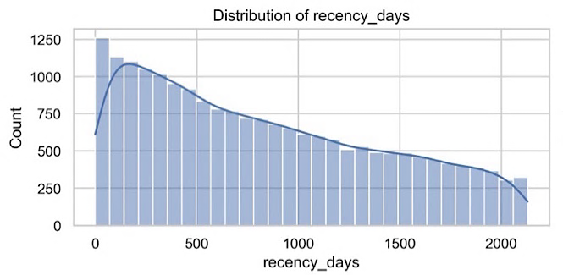

Order frequency and revenue were highly right-skewed: most customers purchased once or twice, while a small minority generated disproportionately high revenue
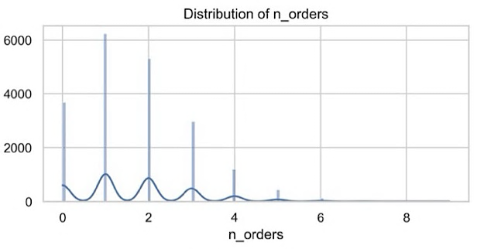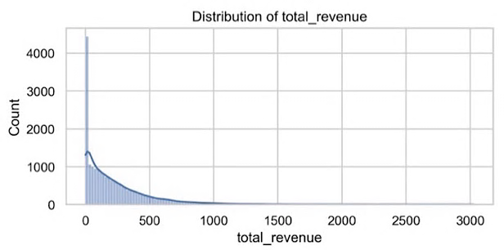
Product and category diversity also showed strong skew: most customers purchased only a few unique products from one category, while a small group shopped broadly across categories.
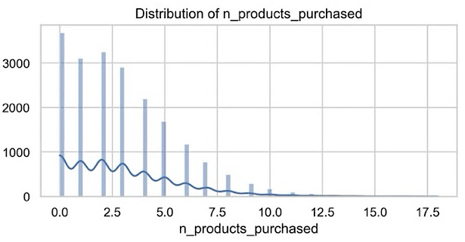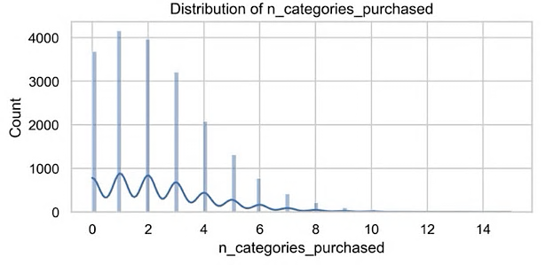
.
mean_order_value and total_qty_purchased were mathematically tied to revenues and orders, and therefore redundant. These were dropped before PCA.

Funnel Engagement: Distinct Patterns in Browsing, Intent, and Conversion

Funnel features—including events, views, add-to-cart actions, checkouts, purchase events, sessions with activity, and conversion rates—revealed meaningful differences in how customers interact with the website:

Browsing intensity (events, views) clustered around moderate levels, with a long tail of highly engaged users.

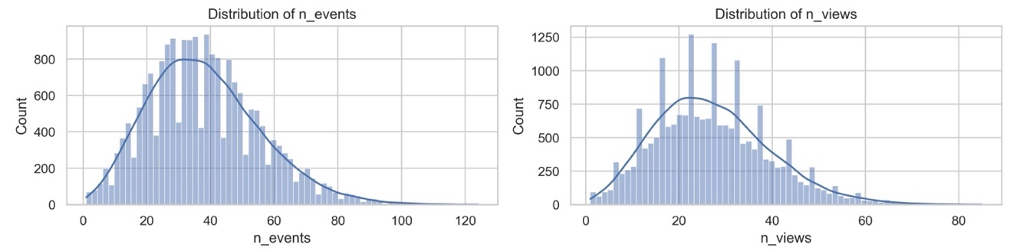

Add-to-cart, checkout, and purchase events showed large drop-offs as customers moved down the funnel, indicating high abandonment and funnel friction.
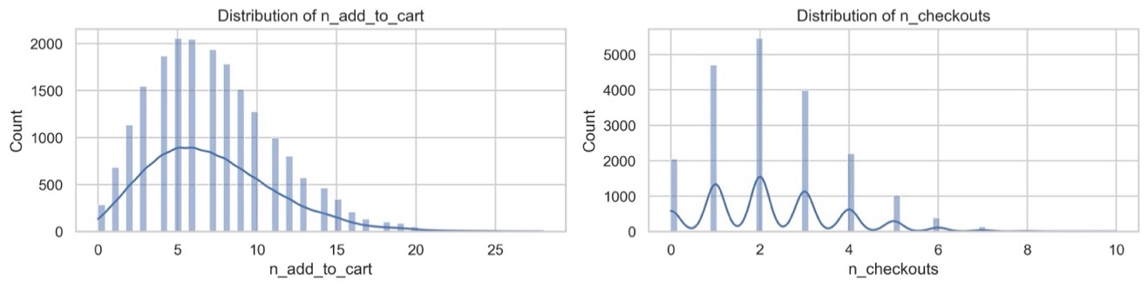
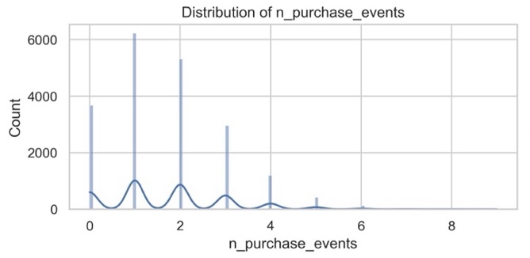

Sessions with events showed that engagement often occurred across multiple visits, not just single sessions. | 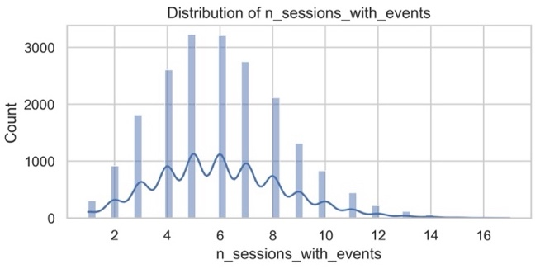

Conversion efficiency metrics (cart-to-view rate, purchase-to-cart rate) displayed wide variation, distinguishing decisive buyers from window shoppers and abandoners.
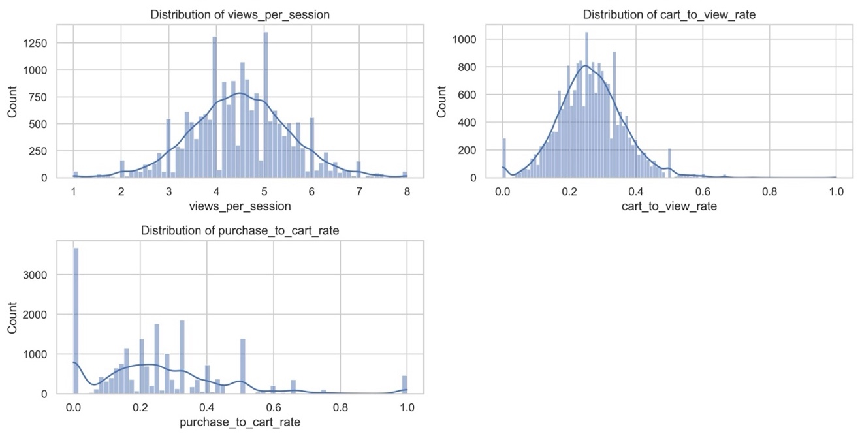

Combined Insights: A Multi-Dimensional Customer Landscape
Together, RFM and funnel insights suggested a customer base with diverse behaviors across value, engagement, and conversion efficiency:
- RFM features captured lifetime value and purchase history, while funnel features captured shopping behavior and intent.
- Both sets of variables showed strong right skew and long tails, confirming the presence of extreme but meaningful high-value users.
- Multiple features clustered into tightly correlated groups (e.g., events and views; orders, revenue, and quantity purchased), indicating redundancy that must be addressed through feature selection or dimensionality reduction.
- Conversion rates and variety metrics offered unique and non-redundant behavioral signals that will be valuable for segmentation.

Implications for Segmentation and Modeling

These exploratory patterns justify a segmentation approach that integrates both value-based (RFM) and behavior-based (funnel) dimensions. They also support:
- Feature reduction to remove redundant metrics.
- Transformations and scaling due to strong skew.
- PCA to capture underlying behavioral dimensions.
- Clustering to uncover distinct personas such as:
  - High-value loyalists
  - Lapsed high spenders
  - Occasional buyers
  - Window shoppers
  - Cart abandoners
  - Browsing-heavy but low-conversion users

C. Outliers, and Statistical Diagnostics
- Outlier analysis using the IQR method showed expected heavy-tailed behavior, particularly among revenue and engagement features.
- Most outliers represented legitimate high-value or high-activity customers, not data anomalies, and was retained in the dataset.
- Numerical skewness was high for most monetary and count-based variables, confirming the need for log transformation and scaling during preprocessing.
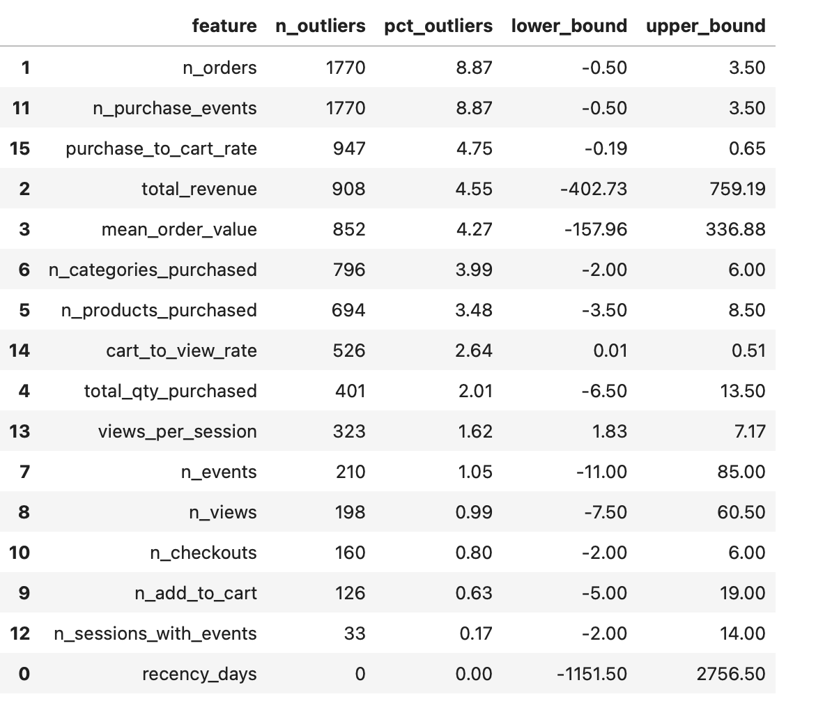

D. Correlation Analysis

Overall summary: The correlation heatmap revealed strong multicollinearity among monetary (RFM) features and among engagement/funnel features. Revenue, frequency, and quantity metrics formed a tightly correlated block, indicating they represent overlapping aspects of customer value. Similarly, page views, events, and add-to-cart activity formed another correlated block representing engagement intensity. Category-level purchase and revenue features also showed strong internal correlation but limited differentiation, suggesting the need for dimensionality reduction. Recency exhibits expected negative correlations with both value and engagement metrics. These findings motivated feature reduction and PCA in the modeling phase to remove redundancy and stabilize clustering.

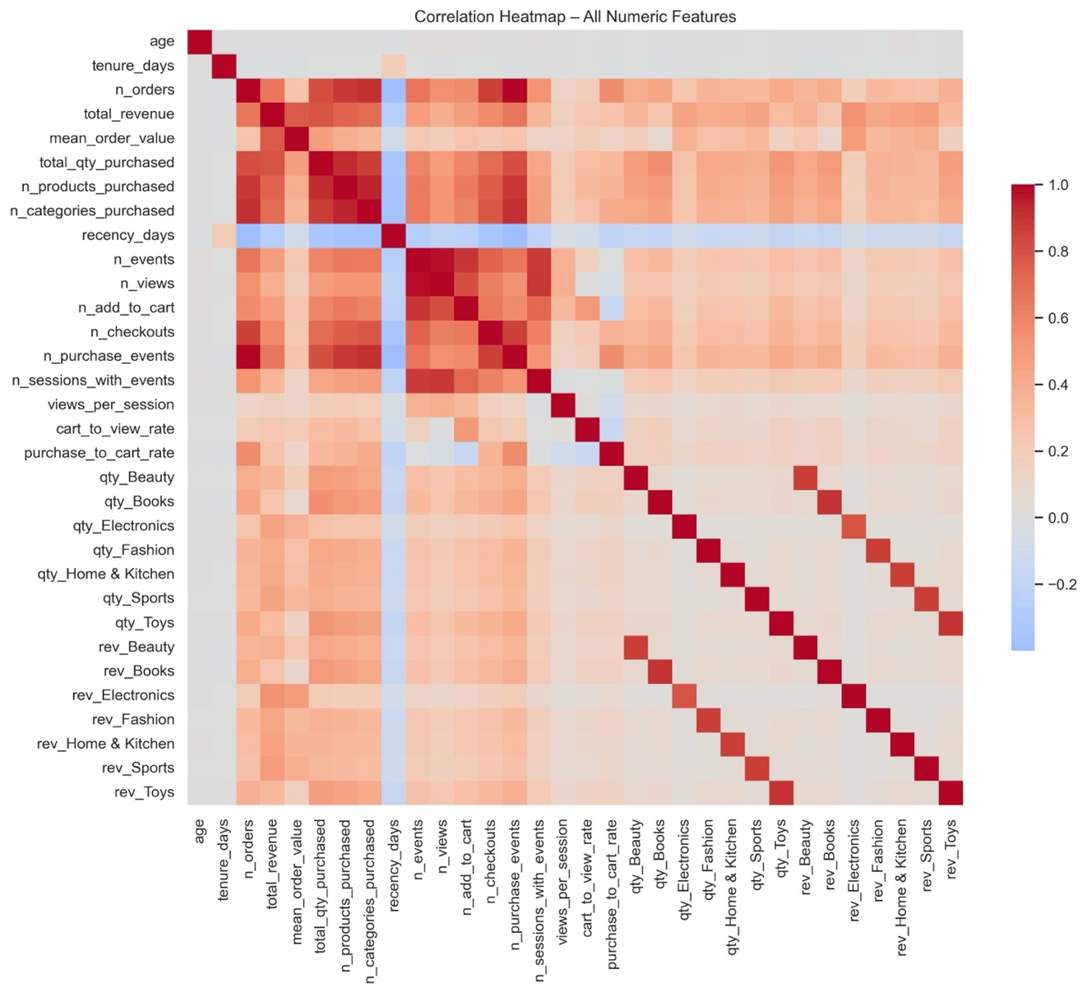

Heatmap Details

1. Very High Correlation Cluster: Monetary + Frequency + Quantity (RFM Block)
This block includes:

total_revenue n_orders n_products_purchased
mean_order_value total_qty_purchased n_categories_purchased

Interpretation
- Customers who bought a lot of products also spent more.
- Customers who bought across more categories also tended to have higher basket sizes and order frequency.
- RFM features were not independent — they reflected the same broad concept: “customer purchasing power or value.”

Action:
- Do NOT drop these features. They each represent a different behavioral angle.
- But they will create redundancy → PCA will naturally collapse them into 1–2 principal components.
- Log-transform monetary variables before PCA.

2. Engagement / Funnel Activity Cluster
There was a strong vertical and horizontal block of correlations in the center-left of the heatmap. This cluster was also deep red across:

n_events n_checkouts n_sessions_with_events
n_views n_purchase_events views_per_session
n_add_to_cart

Interpretation
- Customers who viewed more pages also tended to add more items to cart and checked out more often.
- Funnel metrics collectively represented engagement intensity.
- These variables reflected a single behavioral construct: how active or exploratory the customer is.

Action:
- Keep funnel-level features, but don’t include too many—redundancy is high.
- PCA will compress this into 1 principal component capturing “engagement intensity.

3. Category Quantity Block and Category Revenue Block
  - Category quantity features formed a tight group (strong correlation within themselves).
  - Category revenue features were also tightly correlated WITH each other.
  - Cross-correlation between qty and rev columns were also strong.

Interpretation
- If a customer buys a lot in one category, they are likely heavy in other categories too (general shoppers).
- Revenue by category behaves similarly.
- Category-level features are sparse and redundant.

Action:
- Reduce these to a single behavioral measure → category_variety
- PCA will also help remove redundancy if you keep them.

4. Recency was Uniquely Negative (Blue region)
recency_days had negative correlations with almost all RFM and engagement variables. This means that customers who hadn't purchased recently, bought less, had fewer orders, had lower revenue and had fewer events.

Interpretation: Recency is an inverse indicator of engagement/value, which is expected in RFM.

Action:
- Keep recency_days as-is.
- Ensure scaling (StandardScaler) because its range is large

5. Weak correlations observed for Tenure and Age. These were dropped.

3.3 Pre-Processing and Modeling

A. Data Source & Preparation

Started the process with a customer-level aggregated dataset (customer_model_df) containing behavioral metrics such as:
- RFM metrics: recency, number of orders, total revenue
- Engagement metrics: events, views, add-to-cart counts, sessions-with-events
- Variety metrics: number of products and categories purchased
- Conversion metrics: cart-to-view rate and purchase-to-cart rate
- Demographics: age, country, marketing opt-in flag

Feature Selection - deliberately kept only behavioral numeric features for clustering because:
- They are most predictive of behavioral similarity
- They avoid demographic bias
- They produce segments actionable for marketing intervention

Excluded:
- Category-level quantities, redundant features
- Dummy-encoded demographic flags
- Country and marketing opt-in (used only for profiling, not clustering)

B. Preprocessing
Three main steps prepared the data for clustering:

1. Log-Transforming Skewed Variables
Highly skewed count/revenue variables were log-transformed using np.log1p() to reduce the effect of extreme values.

2. Standardization - All transformed numeric features were standardized using StandardScaler().

3. PCA Dimensionality Reduction
Principal Component Analysis (PCA) was performed reduce noise, reduce dimensionality and improve clustering performance.

Based on the scree plot and cumulative explained variance, four (4) principal components were retained. These components capture over 90% of the total variance and represent the point of diminishing returns, beyond which additional components contribute minimal explanatory power.

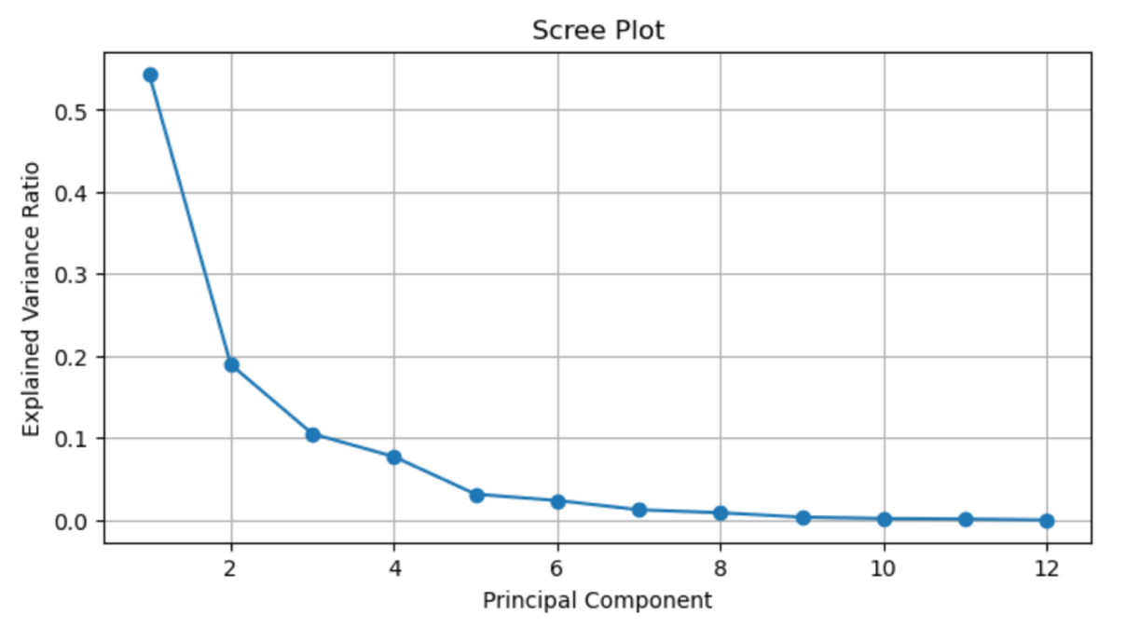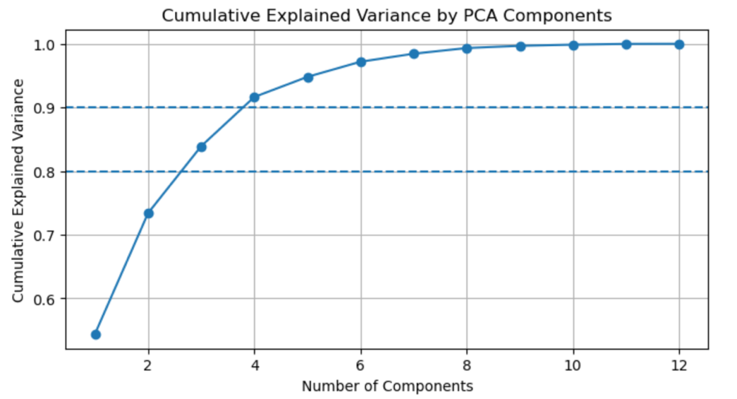

C. Model Selection & Optimization

To ensure a robust and business-relevant customer segmentation, three complementary clustering approaches were evaluated: K-Means, Agglomerative Hierarchical Clustering, and DBSCAN. K-Means provided a clear baseline by identifying broad, central customer groupings under simple structural assumptions. Agglomerative clustering offered insight into hierarchical relationships and natural group formation without predefining the number of segments. DBSCAN was included to capture real-world behavioral complexity, allowing clusters of uneven size and shape while explicitly identifying noise and outliers. Evaluating multiple models reduced reliance on a single assumption and ensured that the final segmentation reflected genuine customer behavior patterns rather than algorithmic artifacts.

Model / Key Assumptions | Strengths / Limitations | Why It Was Included
K-Means  Centroid-based  Clusters are spherical and similar in size; number of clusters must be specified | Strengths: Fast, scalable, easy to interpret; strong baseline  Limitation: Sensitive to outliers, forces all points into clusters | Provides a simple, interpretable benchmark for broad customer segmentation
Agglomerative  Hierarchical  Distance-based similarity; no fixed cluster shape | Strengths: Reveals hierarchical structure; flexible cluster granularity  Limitations: Computationally intensive, no noise handling | Helps understand how customer groups naturally merge and separate
DBSCAN  Density-based  Clusters are dense regions separated by sparse areas | Strength: Handles arbitrary shapes; identifies noise; no preset cluster count  Limitation: Sensitive to parameter choice, cluster sizes may vary | Best reflects real customer behavior patterns and isolates outliers

Result: DBSCAN revealed natural, non-linear clusters that K-Means could not detect.
Higher silhouette and lower DBI confirm better separation.

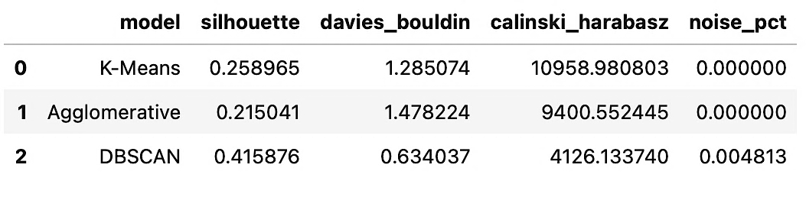

Details of Models

1. K-Means Optimization
Tested K = 2 to 10 clusters:
- Elbow method suggested K ≈ 4
- Silhouette scores also supported K = 4glo
- K-Means gave reasonable structure but moderate separation (silhouette ≈ 0.26)

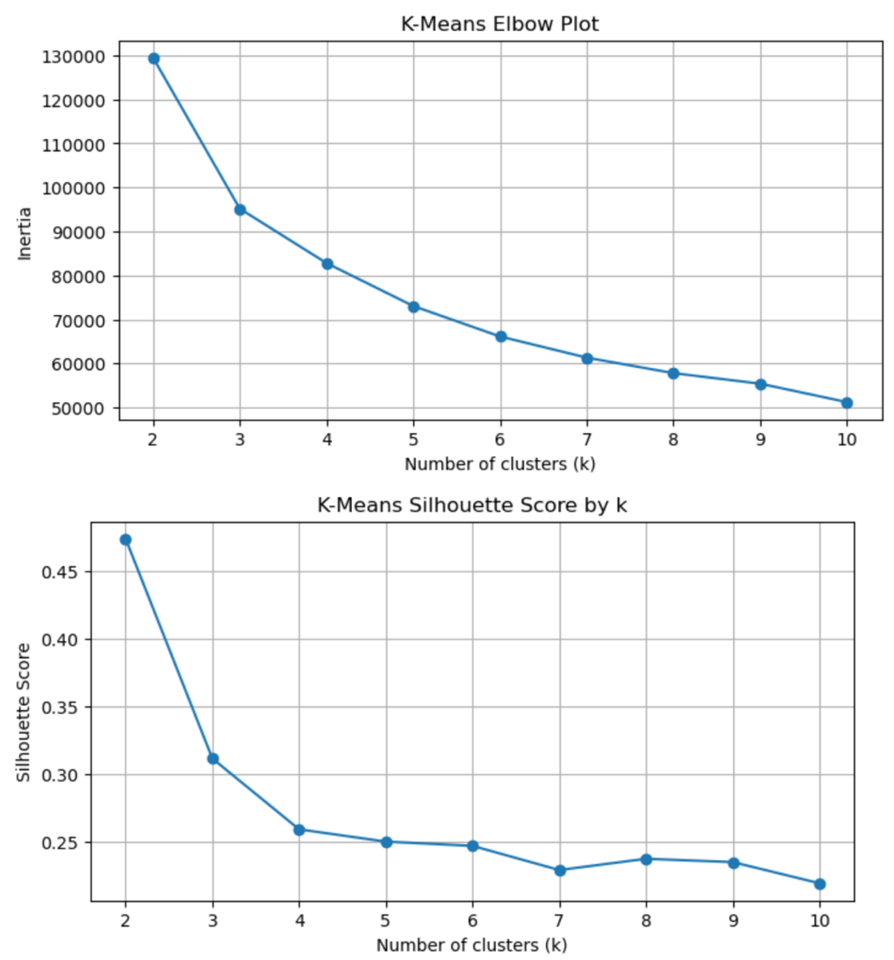

2. Agglomerative Clustering
Performed similarly to K-Means but with slightly worse internal metrics.

3. DBSCAN Hyperparameter Tuning
DBSCAN was tuned using a manual grid search over:
- eps (0.2 to 1.0)
- min_samples (5, 10, 15)

For each configuration we computed:
- Silhouette
- Davies–Bouldin
- Calinski–Harabasz
- Noise proportion
- Number of clusters
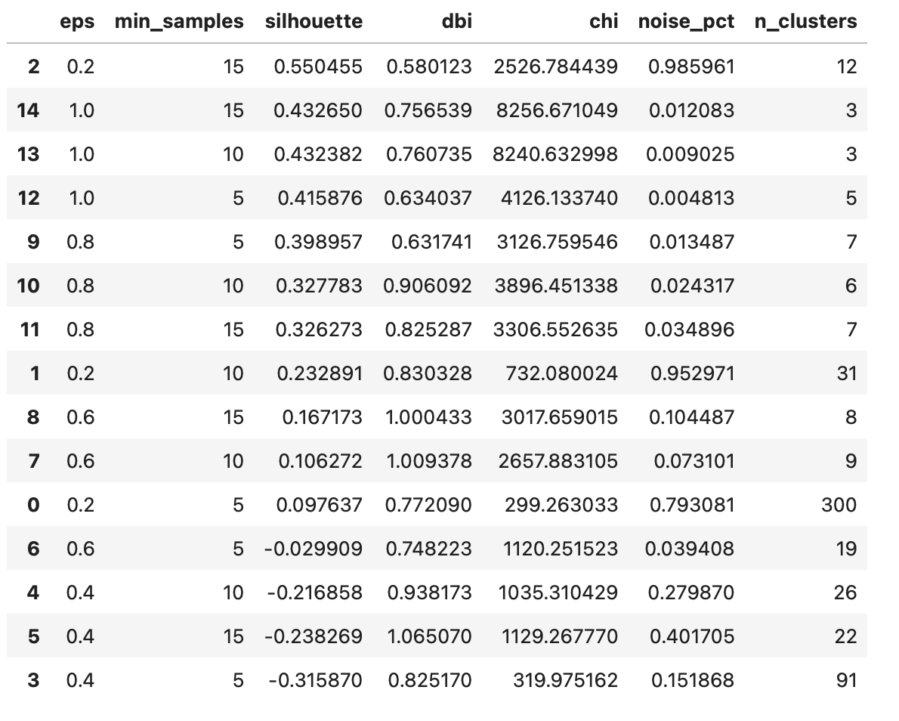
Best configuration:  - eps = 1.0  - min_samples = 5 | This model produced:  - 5 meaningful clusters  - 0.48% noise  - Silhouette = 0.416 (best of all models)  - Davies–Bouldin = 0.63 (best)  - Strong Calinski–Harabasz for a density model

This outperformed both K-Means and Agglomerative, making DBSCAN the final chosen model.

D. DBSCAN Cluster Profiling & Insights
The final model revealed five actionable customer segments:
- Engaged Browsers – Explore often, add items to cart, but rarely convert.
- High-Intent Multi-Category Researchers – Highly engaged, browse multiple categories, strong purchase potential.
- Window Shoppers – Frequent site visitors who never purchase.
- Focused One-Category Buyers – Efficient, decisive buyers with strong category focus and perfect conversion.
- Quick Converters / Infrequent Buyers – Convert instantly but purchase rarely; ideal for replenishment strategies.
- (Plus a negligible <1% noise cluster.)
These segments offer substantial value for marketing teams. High-intent and high-conversion segments provide opportunities for personalized recommendations and loyalty growth, while low-engagement or zero-purchase segments benefit from onboarding flows, incentives, and simplified guidance.

Cluster Sizes

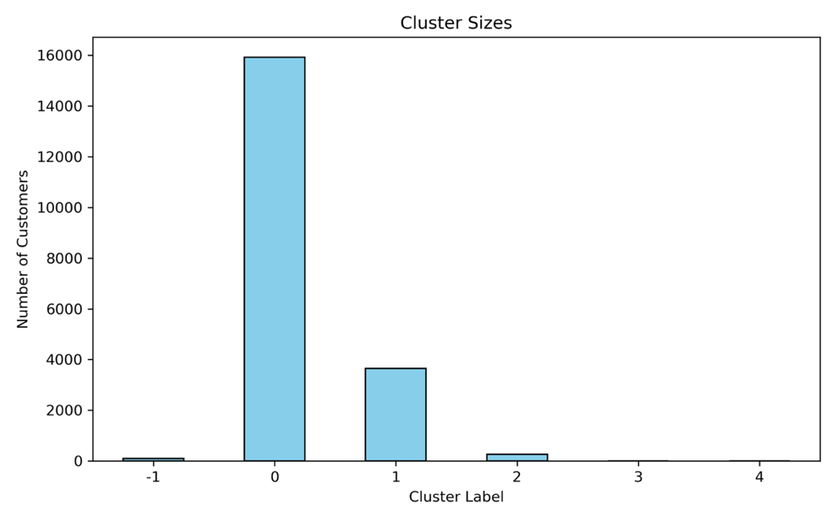
The cluster size distribution highlights the natural density patterns DBSCAN identified in the customer base. Cluster 0 dominates the population, representing over three-quarters of all customers and forming the platform’s core user base with moderate engagement and steady purchase activity. Cluster 1 forms the second-largest group, capturing a sizable set of low-activity browsers who interact with the site but rarely convert. The remaining clusters (2, 3, and 4) are much smaller, representing high-intent niche behaviors The noise cluster (–1) is extremely small, indicating that DBSCAN found coherent structure without misclassifying large portions of the dataset. Overall, the distribution is expected for behavioral segmentation, where most customers fall into broad engagement tiers and only a minority exhibit high-value or highly specialized patterns.

The PCA scatter plot

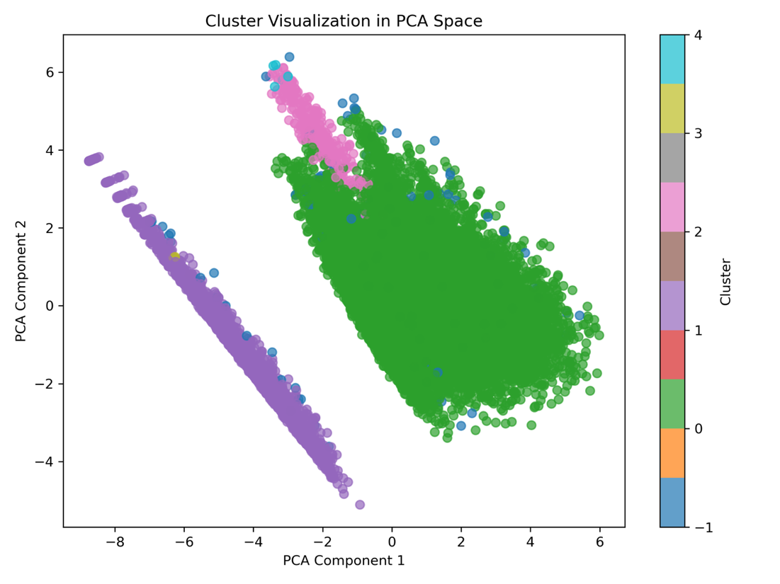
While only three major shapes appear in the plot, this is expected because PCA compresses many behavioral dimensions into just two components, causing some clusters to overlap or appear blended. Despite this visual overlap, the underlying DBSCAN clustering remains valid, as confirmed by strong internal metrics and the clear behavioral differences observed in the heatmaps and profiling tables.

Visualizing the Clusters - Radar Chart 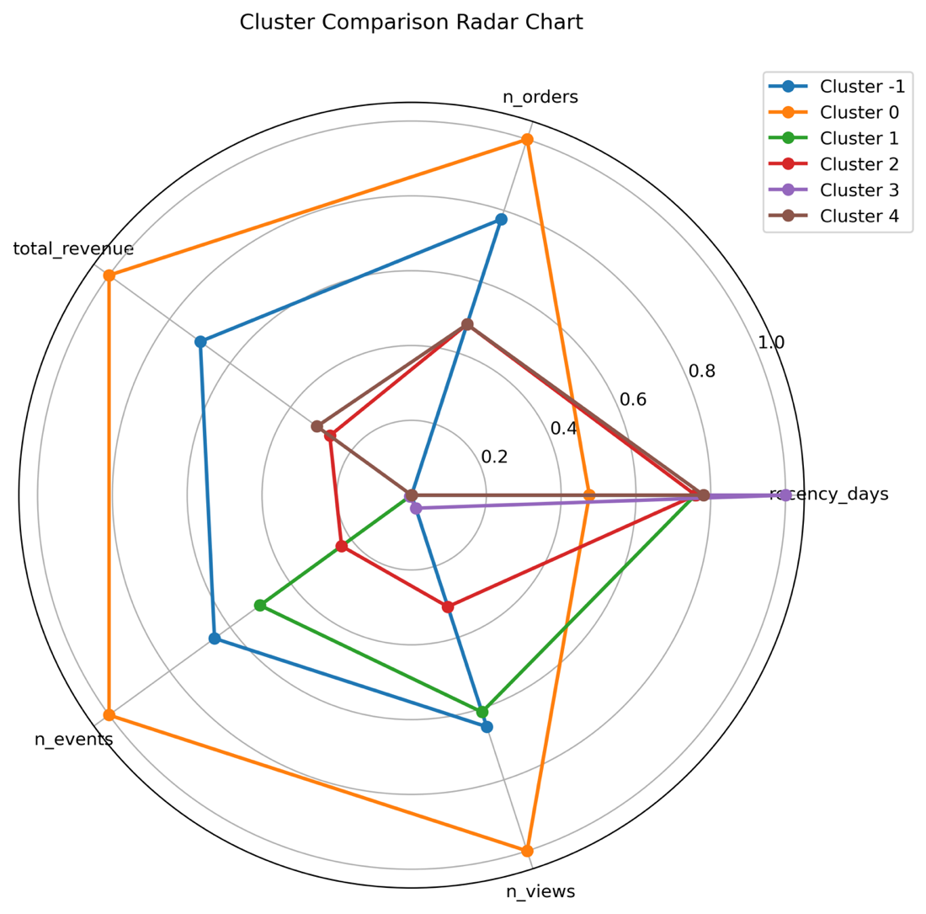
The radar chart highlighted clear behavioral differences across the five DBSCAN clusters.
- Cluster 0 stood out immediately with the highest levels of engagement—leading all clusters in orders, revenue, events, and views—indicating a highly active, high-intent customer group.
- Clusters 1 and 3 showed very low activity across all features, reflecting window shoppers or low-engagement visitors with limited intent to purchase.
- Cluster 2 displayed moderate but focused behavioral patterns aligned with a single-order, single-category buyer profile.
- Cluster -1, although categorized as noise by DBSCAN, exhibited steady and consistent mid-level engagement, suggesting exploratory behavior without strong purchase intent. Overall, the radar plot visually reinforces the distinct behavioral identities of each cluster and validates the segmentation structure uncovered by the DBSCAN model.

Visualizing the Clusters - Engagement + Variety Heat Map

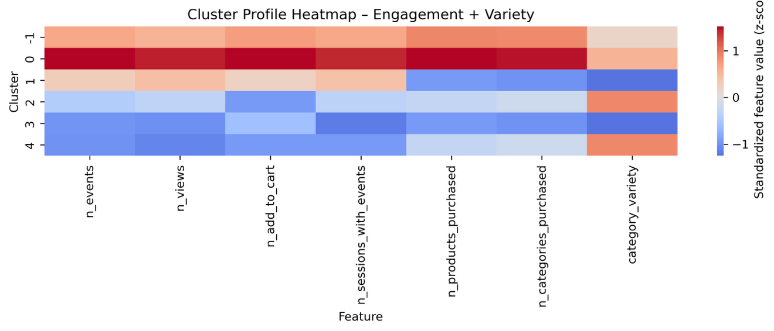

The Engagement + Variety heatmap highlighted strong differences in how clusters interacted with the platform and diversify their purchasing behavior.

- Cluster 0 clearly emerged as the most active group, showing the highest levels of events, views, add-to-carts, and sessions with meaningful engagement, as well as the greatest product and category variety.
- Cluster −1 also demonstrated above-average engagement, although with lower variety than Cluster 0, suggesting exploratory users who browsed widely but purchased more selectively.
- Cluster 1 showed moderate engagement but very low variety, reinforcing its identity as a window-shopping segment with limited intent.
- Cluster 2 displayed modest engagement but relatively higher variety than the low-intent clusters, aligning with focused single-category shoppers.
- Clusters 3 and 4 were the least active across all engagement metrics, with Cluster 4 showing slightly higher variety due to its decisive purchase behavior despite minimal browsing.

Overall, the heatmap validated meaningful behavioral differentiation across clusters in terms of engagement depth and shopping variety.

Visualizing the Clusters - Age Breakdowns
Only Cluster 3 is distinct in terms of age profile. It is generally an older co-hort than than other clusters.
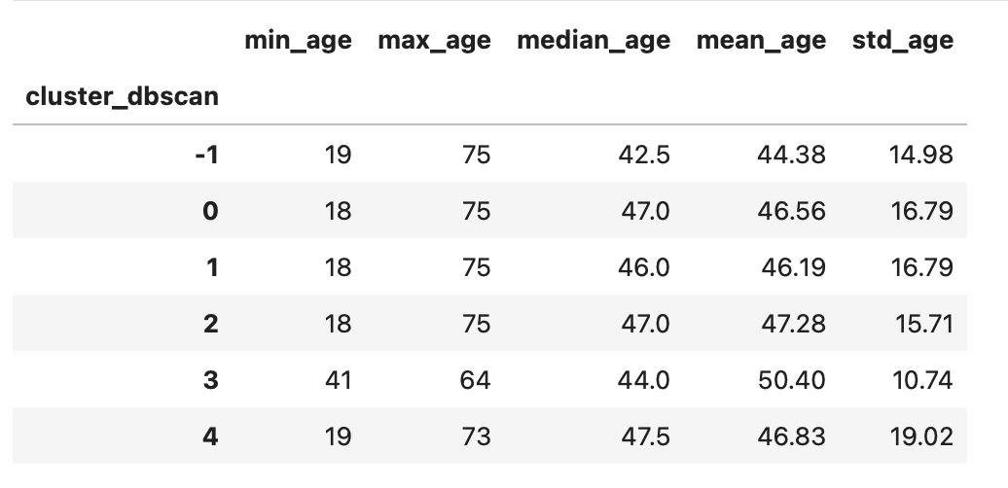

Visualizing the Clusters - Country Compositions
Clusters 3 and 4 stand out have meaningfully different country compositions than the others. Cluster 3 has no US and Mexican representation. Customers in Cluster 4 over-index from US, Mexico and Spain
Cluster | -1 | 0 | 1 | 2 | 3 | 4

Visualizing the Clusters - Country Compositions
Marketing opt in for all clusters in >50 % , and is > 80% for clusters 3 & 4. | 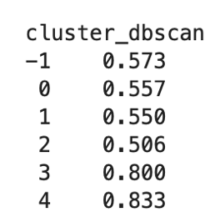
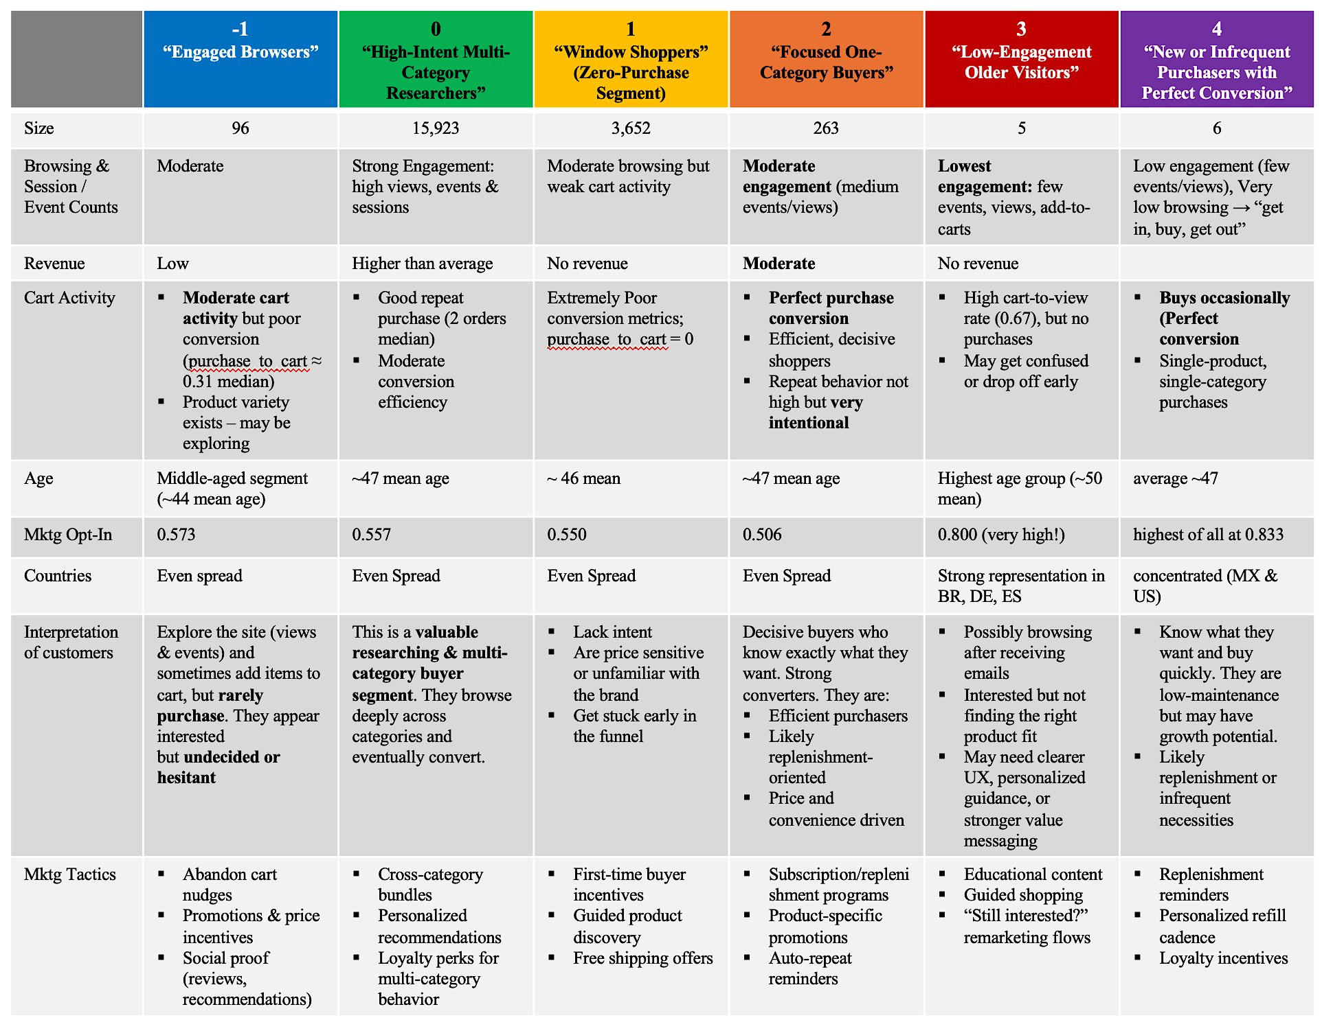
Summary of Clusters

3.4 Recommendations & Future Research

Recommended Actions

The customer segmentation model identified five distinct behavioral segments with clear implications for marketing activation and experience design.

High-intent, highly engaged segments should be prioritized for personalization, cross-sell, and loyalty initiatives. Their strong browsing depth, category exploration, and purchase efficiency make them ideal candidates for tailored recommendations, early access offers, and replenishment or subscription programs.

Lower-intent segments, including window shoppers and low-engagement browsers, should be supported through onboarding and education rather than aggressive promotion. Simplified navigation, curated entry points, and light incentives can reduce friction and move these customers further down the funnel.

Focused, efficient buyers present an opportunity to increase purchase frequency rather than conversion. Convenience-driven tactics such as one-click reorders, reminders, and category-specific loyalty benefits are most effective for this group.

Critically, segmentation outputs should be operationalized as persistent customer attributes and integrated into downstream marketing systems, rather than remaining static analytical results.

Future Research

Future work should assess segment stability over time to understand migration patterns and identify early signals of churn or value growth. Linking segments to economic metrics such as lifetime value, retention, and acquisition cost would enable prioritization based on profitability, not behavior alone.

Additional research could incorporate richer product affinity and price sensitivity signals, and validate segments through supervised downstream models to quantify incremental lift from segment-based targeting.

Finally, A/B testing should be conducted to identify the most effective messaging and offers for each segment, particularly among high-intent and highly engaged customers.

Click Stream Purchase Prediction Model

4.0 PURCHASE PREDICTION MODEL

4.1 Feature Engineering and Data Integration
To prepare the combined dataset for modeling and analysis, several features were engineered from the events df, such as:

target_purchase (flag) event counts: session_duration
n_events add_to_cart
n_distinct purchases checkout
total_quantity page_view
total_revenue_session purchase
ave_discount_session

Created session_model_df by merging engineered features, customer information from customers df and sessions df.

4.2 Exploratory Data Analysis (EDA)
The goal of the EDA stage was to understand the structure, distributional properties, and behavioral patterns within the session-level dataset in preparation for building a model to predict whether a session results in a purchase. This analysis also identified potential data quality issues, multicollinearity, outliers, and risks of data leakage.

A. Dataset Structure and Data Types
- Timestamp fields (start_time, signup_date) were converted from object → datetime.
- The dataset contained a mix of numeric behavioral features, categorical session attributes, and a binary target variable (target_purchase).
- ID fields (customer_id, session_id) were excluded from numerical summaries and modeling considerations, as they do not carry predictive signal.

B. Target Variable Distribution
- 28% purchase vs. 72% non-purchase.
- This represented moderate class imbalance (not extreme).
- Class-balancing methods may be considered, but tree-based models typically handles this well.

C. Univariate Analysis

Numerical Features
- Behavioral variables such as n_events, total_quantity, total_revenue_session, and session_duration_min showed right-skewed distributions with long tails.
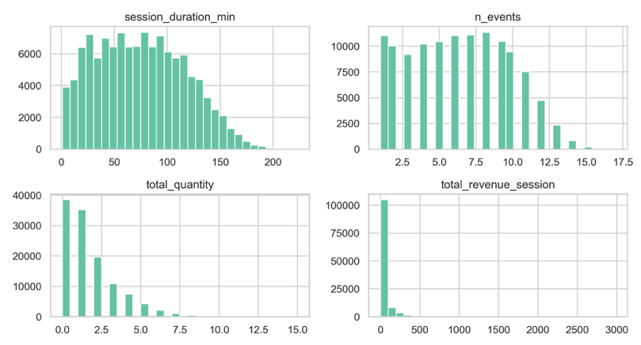
- Outliers were present across several behavioral features but these are expected in real user behavior and were handled through log transformation and robust scaling, not removal.

Categorical Features
- Device type, traffic source, marketing opt-in, and country were unevenly distributed but showed no major data quality issues.
- Most sessions originated from mobile and desktop; the USA is the largest country segment.

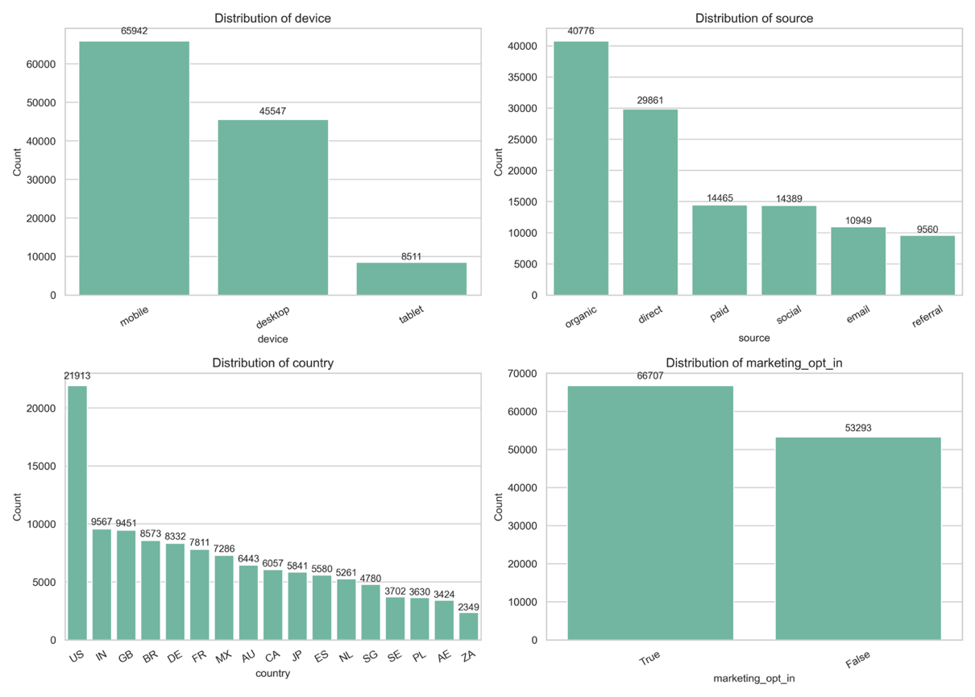

D. Bivariate Analysis

Numeric Features vs. Target - Clear differences emerged between purchasing and non-purchasing sessions:

Purchasers have significantly higher engagement: | Purchasers show greater funnel progression:
- More events  - More page views  - More distinct products viewed | - Higher add-to-cart counts  - Higher checkout rates  - Higher quantities and revenue (though revenue/quantity may contain leakage)

These variables represented the strongest predictive signals in the dataset.

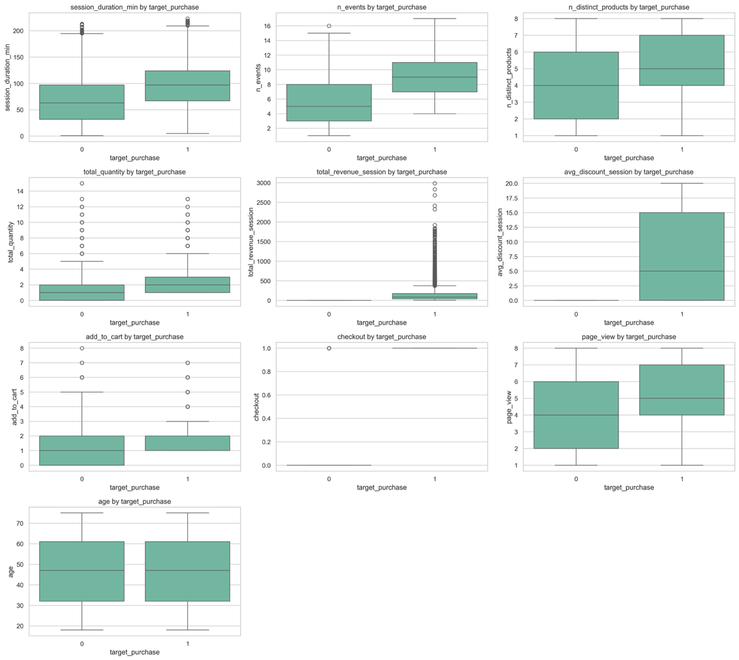

Categorical Features vs. Target
- Purchase rates were very similar across all categories of device, traffic source, country, and marketing_opt_in.
- Category-level attributes showed minimal predictive separation on their own.
- They may still provide weak complementary signal when combined with behavioral features.

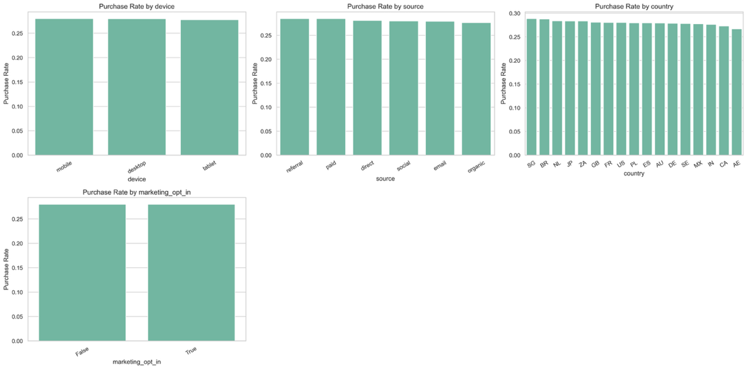

E. Interaction / Behavioral Insights - Interaction plots reinforced that engagement intensity drives conversion:

- Longer sessions → higher purchase likelihood
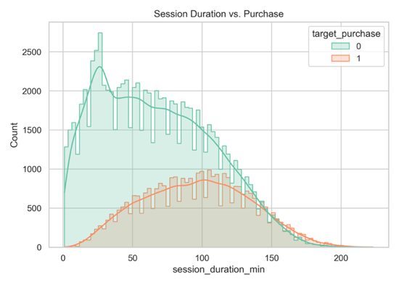
- More events, page views, and product exploration → higher conversion
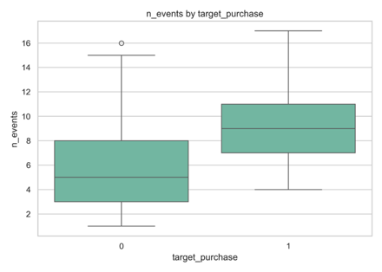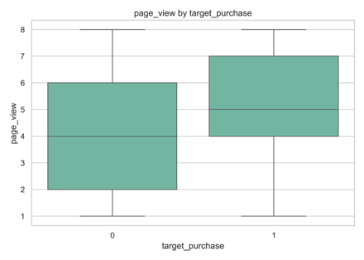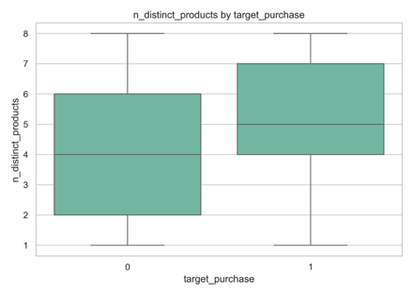

- Add-to-cart and checkout behaviors strongly differentiate purchasers
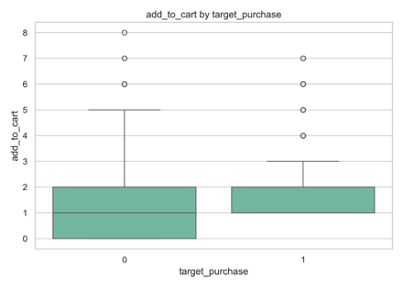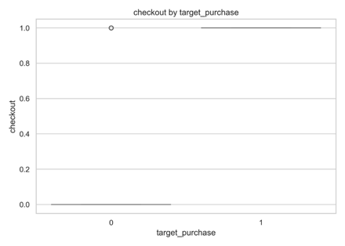

These patterns are intuitive and validate the behavioral funnel.

Funnel features (checkout - above, revenue, quantity, discount) were checked and confirmed for data leakage.

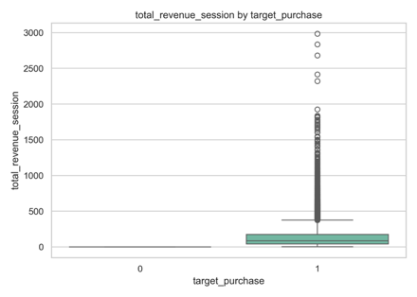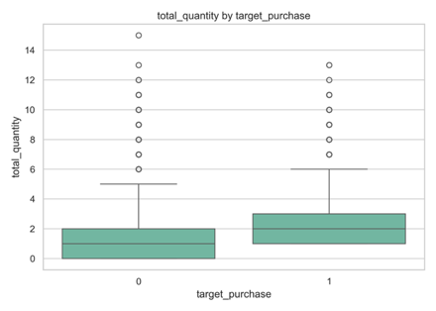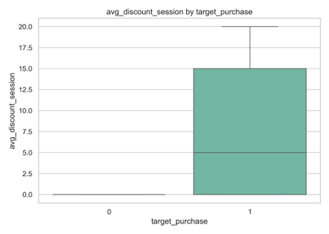

F. Correlation Analysis -

1. Two clear feature clusters emerged:
  - Engagement cluster: n_events, n_distinct_products, page_view, session_duration_min
  - Funnel progression cluster: total_quantity, add_to_cart, checkout, total_revenue, avg_discount_session
2. Moderate multicollinearity existed within these clusters, but this was expected and generally not harmful for tree-based models.
3. Age showed nearly zero correlation with all features, indicating limited predictive value.
4. The target variable was intentionally excluded from the heatmap to avoid distortion.

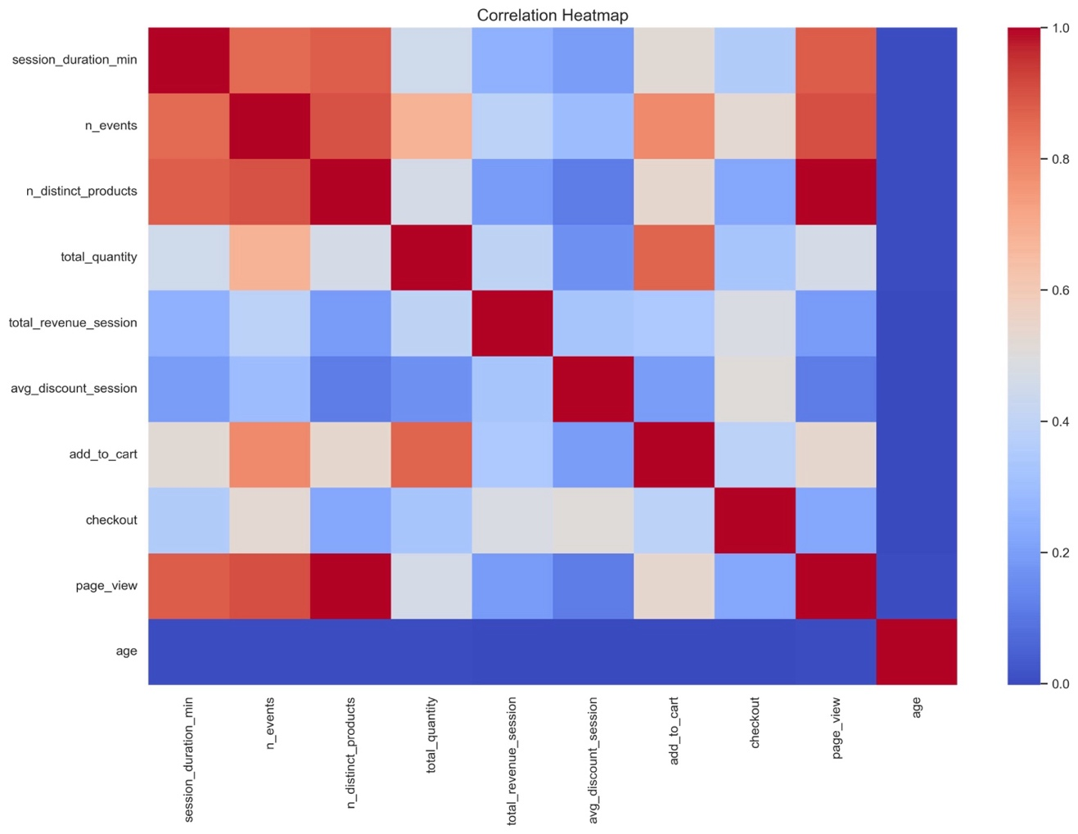

G. Leakage Assessment

Potential leakage was identified in several features that appear to contain post-purchase information:
- total_revenue_session
- total_quantity
- avg_discount_session
- checkout

These fields correlate strongly with purchase simply because their values change after a purchase occurs. Final decisions on leakage will be made in preprocessing, but these features must be treated cautiously and possibly removed or replaced with pre-purchase equivalents.

add_to_cart was validated to be generated in real-time, indicating it was safe to include in the model.

H. Outlier Handling Strategy
- Outliers reflected real user behavior (e.g., long sessions, high purchase quantities) rather than errors.
- Outliers will be handled via:
  - Log transformation
  - Robust scaling
- No rows were removed solely due to outliers.

I. Overall EDA Conclusions
- Behavioral session features drove purchasing behavior and represented the core predictive power for the model.
- Categorical features offered weak predictive separation and will supplement, not lead, model performance.
- Data leakage is a critical concern for funnel-completion features and must be prevented during preprocessing.
- Outliers and skewness were expected and will be managed through transformation rather than deletion.
- The dataset is well-suited for tree-based models, which naturally handle nonlinearity, skewed distributions, and multicollinearity.

4.3 Pre-Processing and Modeling

A. Pre-Processing Approach
  - Following EDA, a rigorous, leakage-aware pre-processing strategy was implemented to ensure that all models reflected forward-looking, actionable prediction rather than post-outcome signals. Confirmed leakage variables— checkout, total_revenue_session, total_quantity, avg_discount_session, duplicate purchase column —were removed prior to modeling.
  - Outliers in engagement behavior were retained, as they reflected genuine user activity, and were handled via log transformation and standardization rather than removal. Numeric and categorical features were processed using a unified ColumnTransformer pipeline, ensuring consistent and leakage-free transformations across train and test sets.

B. Modeling Strategy
The dataset was split into stratified training and test sets to preserve class balance (test size = 25%, random state = 42)

Logistical Regression, Random Forest Clasifier, Gradient Boosting, KNN were the models chosen for this project.

Model / Configuration | Why use it? | What it tells you?
Logistic Regression (Regularized – Baseline) | - Strong baseline and sanity check  - Interpretable coefficients (directionality of engagement features)  - Performs surprisingly well in behavioral prediction tasks  - Forces discipline around preprocessing | - Which engagement signals most increase purchase probability  - Whether nonlinear models are genuinely adding value
Random Forest Classifier | - Handles nonlinear relationships and interactions naturally  - Robust to outliers (complements your “no removal” decision)  - Provides intuitive feature importance  - Good mid-complexity benchmark | - Whether interactions (e.g., events × session_duration) matter  - Which features dominate prediction when relationships aren’t linear
Gradient Boosting | - Typically top performer for tabular behavioral data  - Excellent at modeling:  - Threshold effects  - Diminishing returns  - Subtle feature interactions  - Handles imbalance well with proper tuning | - The best achievable performance on this dataset  - Where marginal gains come from beyond Random Forest
K-Nearest Neighbors (KNN) | - Captures local behavioral similarity  - Strong when engagement patterns cluster naturally  - Complements tree-based models conceptually  Important caveat: Requires careful scaling, Computationally heavier, but dataset size seems manageable | - Whether “similar sessions behave similarly”  - Whether your feature space clusters meaningfully

1. Initial models achieved near-perfect test performance, which prompted additional diagnostic checks. Given the real-world nature of session-level behavioral data, such performance strongly suggested the presence of a residual proxy or temporal leakage feature.

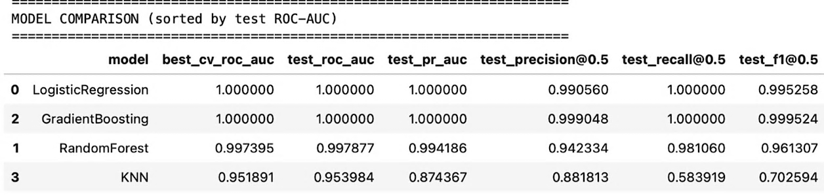

Although add_to_cart was confirmed to be logged in real time, exploratory modeling revealed that it functioned as a temporal proxy for purchase. To preserve forward-looking, actionable prediction, the feature was excluded so the model predicts intent prior to cart commitment.

2. The model was re-run without the 'add_to_cart' feature. Resulting metrics were realistic.

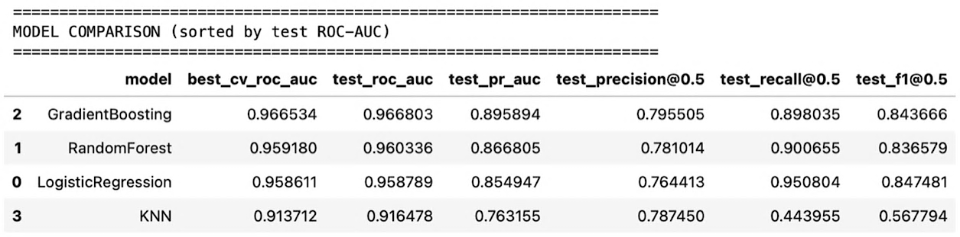

3. The three top-performing models were selected for focused hyperparameter tuning for the final model.

Gradient Boosting was selected due to its strongest overall performance (highest ROC-AUC and PR-AUC), while Logistic Regression and Random Forest provided comparable results and valuable interpretability and recall benchmarks.

Hyperparameters for each model were optimized using stratified 5-fold cross-validation and ROC-AUC as the primary scoring metric. The table below summarizes the best-performing parameter combinations selected for each algorithm.

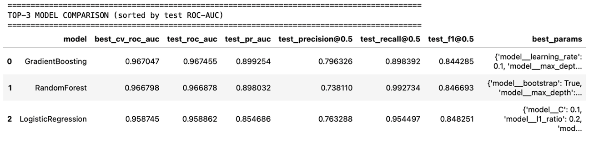
Gradient Bosting scored highest for roc_auc and precision. Random Forest had the highest recall and Logistic Regression topped in F1 score.

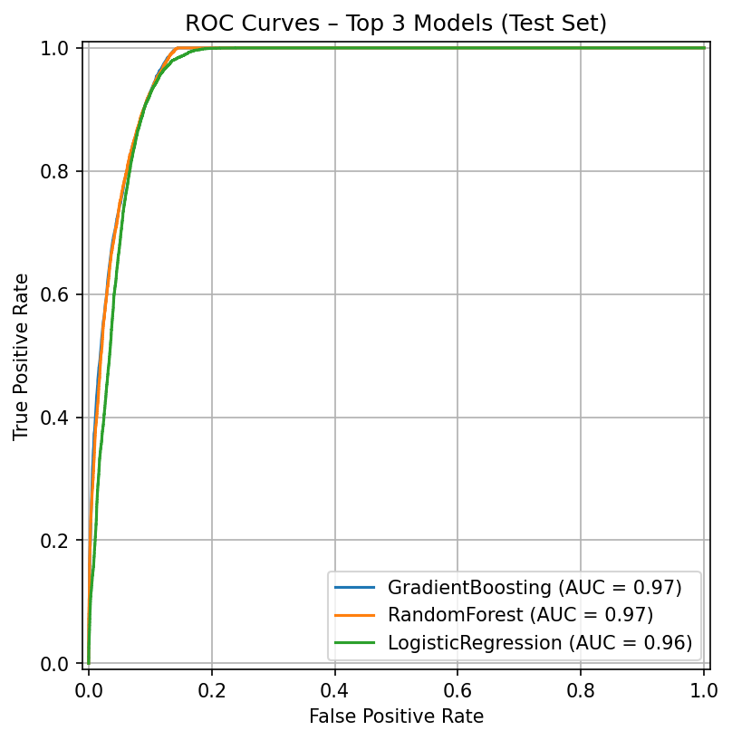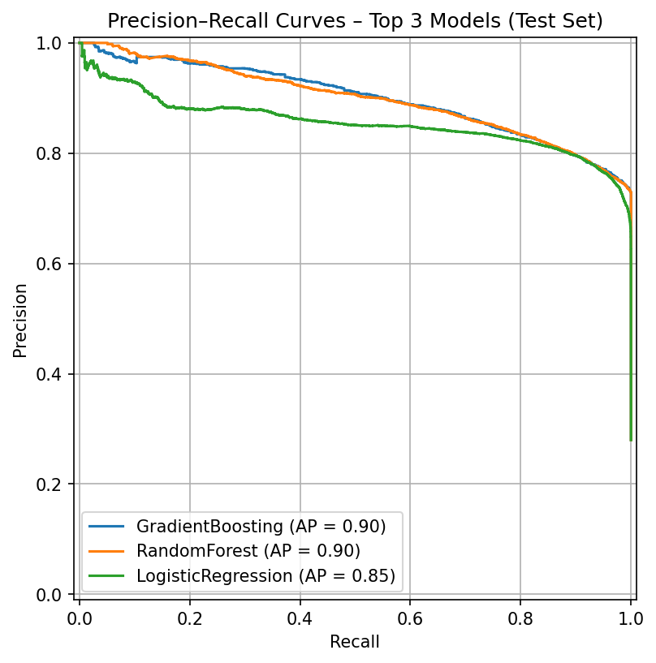
ROC and Precision–Recall curves for the top three tuned models demonstrated comparable ranking performance, with Gradient Boosting showing the strongest overall balance between precision and recall across thresholds.

5. Feature Importance analysis from the Gradient Boosting model indicated that behavioral engagement metrics—specifically page views and number of events—drove the majority of predictive power. Session duration and product breadth provided modest incremental value, while demographic and acquisition attributes contributed minimally. This reinforced the conclusion that real-time engagement intensity is the primary determinant of purchase int

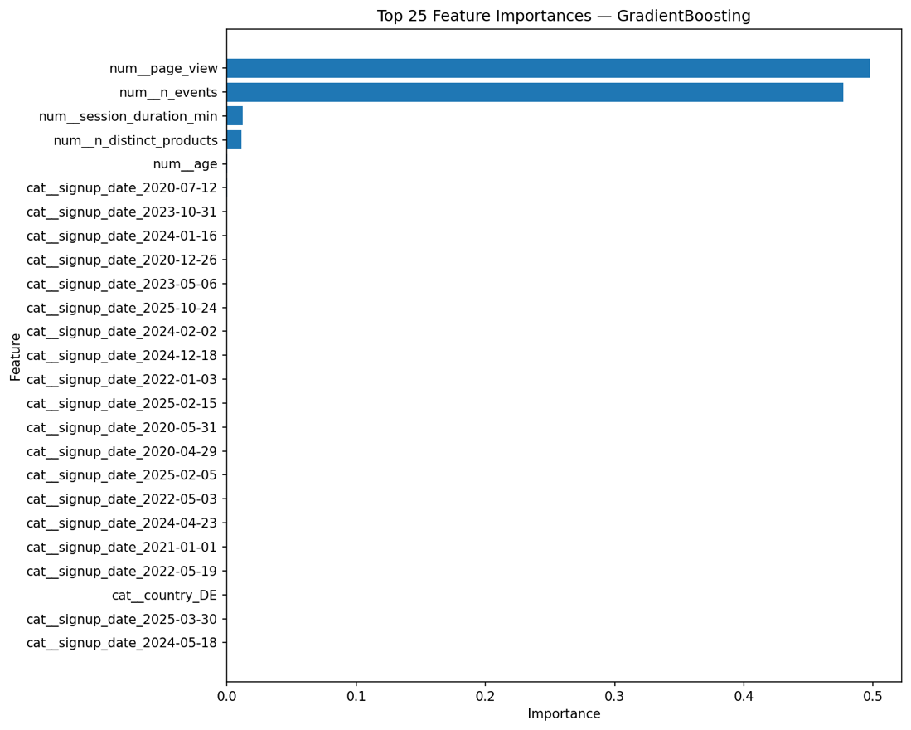

C. Threshold Optimization
Because default probability thresholds are often misaligned with business objectives, decision threshold tuning was performed on the selected Gradient Boosting model. By optimizing the F1-score under a minimum precision constraint, an operating threshold of 0.44 was selected.

At this threshold, the model captures approximately 95% of purchasing sessions while maintaining acceptable precision (~77%), making it well-suited for early-intervention use cases where missing potential buyers is more costly than triggering some false positives. Importantly, threshold tuning adjusted only the classification decision rule and did not alter the trained model or feature importance.

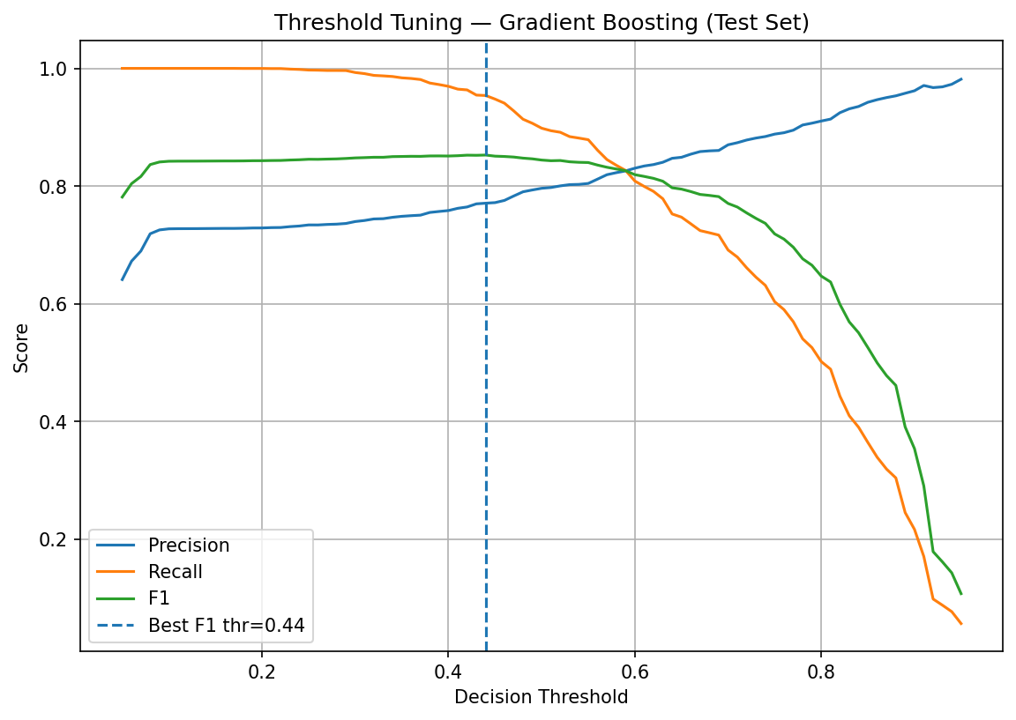

Confusion matrix @ threshold = 0.44
 | Predicted No | Predicted Yes
Actual No | 19,227 (TN) | 2,378 (FP)
Actual Yes | 387 (FN) | 8,008 (TP)

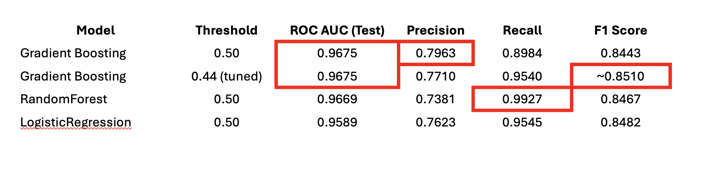

Threshold Tuning Insights
- Threshold tuning was performed on the Gradient Boosting model to balance precision and recall for early purchase-intent detection. The optimal threshold was identified at approximately 0.44, which maximizes the F1-score while maintaining a minimum precision of 0.75. At this operating point, the model achieves 95.4% recall, capturing the vast majority of purchasing sessions, while maintaining 77.1% precision, limiting excessive false positives.
- The confusion matrix confirms that only a small fraction of purchasers are missed, making this threshold well-suited for proactive intervention use cases where recall is prioritized. The smooth trade-off curves indicate stable model behavior across thresholds, supporting robustness of the selected operating point.
- By lowering the decision threshold to 0.44, the model proactively flags high-intent sessions earlier in the customer journey, capturing the majority of potential purchasers while maintaining acceptable precision.

D. Key Findings
- Purchase intent is driven primarily by behavioral engagement intensity, especially page views and total events.
- Tree-based models and logistic regression performed similarly once leakage was removed, underscoring the robustness of the signal.
- Threshold tuning meaningfully improved operational alignment without retraining the model.
- The final model was both high-performing and interpretable, with a clear path to real-world deployment.

4.4 Recommended Actions and Future Research

Recommended Actions

The final Gradient Boosting purchase intent model demonstrated strong predictive performance and was optimized through threshold tuning to support early, in-session intervention.

The primary value of the model is not simply predicting who will buy, but identifying sessions with low or declining purchase probability while the user is still on the site. Framed this way, the model functions as a real-time intent monitor, enabling intervention rather than post-mortem analysis.

In production, the model can dynamically flag both high-intent and at-risk sessions and trigger targeted actions such as checkout assistance, contextual messaging, or limited incentives—improving conversion without broad discounting.

Beyond real-time activation, model outputs can improve marketing efficiency by prioritizing high-intent sessions for retargeting, deprioritizing persistently low-probability traffic, and diagnosing friction across devices, traffic sources, or site flows.

Future Research
Future work could extend the model to predict time-to-purchase, enabling more precise timing of in-session interventions. Sequence-aware approaches (e.g., Markov or neural models) may further capture the order and pacing of user actions.

Combining session-level predictions with customer-level segmentation features may improve precision for returning users. Threshold optimization should also be reframed around economic outcomes, explicitly incorporating incentive cost, margin, and expected incremental lift to enable profit-optimized decision rules.

Finally, A/B testing should be used to evaluate which intervention messages, incentives, and UX treatments drive the greatest incremental conversion for different intent levels, ensuring that model-driven actions translate into measurable business impact.

